**Assignment 1** : S**imple SQL Query with a single table with where clause**

Northwind database Sample table :Products -ProductID -ProductName -SupplierID -CategoryID -QuantityPerUnit -UnitPrice -UnitsInStock -UnitsOnOrder -ReorderLevel –Discontinued

use [Northwind]

go

create table Products

(

ProductID int identity(1,1) not null primary key,

ProductName varchar(50) not null,

SupplierID int not null,

CategoryID int not null,

QuantityPerUnit int not null,

UnitPrice int not null,

UnitsInStock int not null,

UnitsOnOrder int not null,

ReorderLevel int not null,

Discontinued bit not null

);

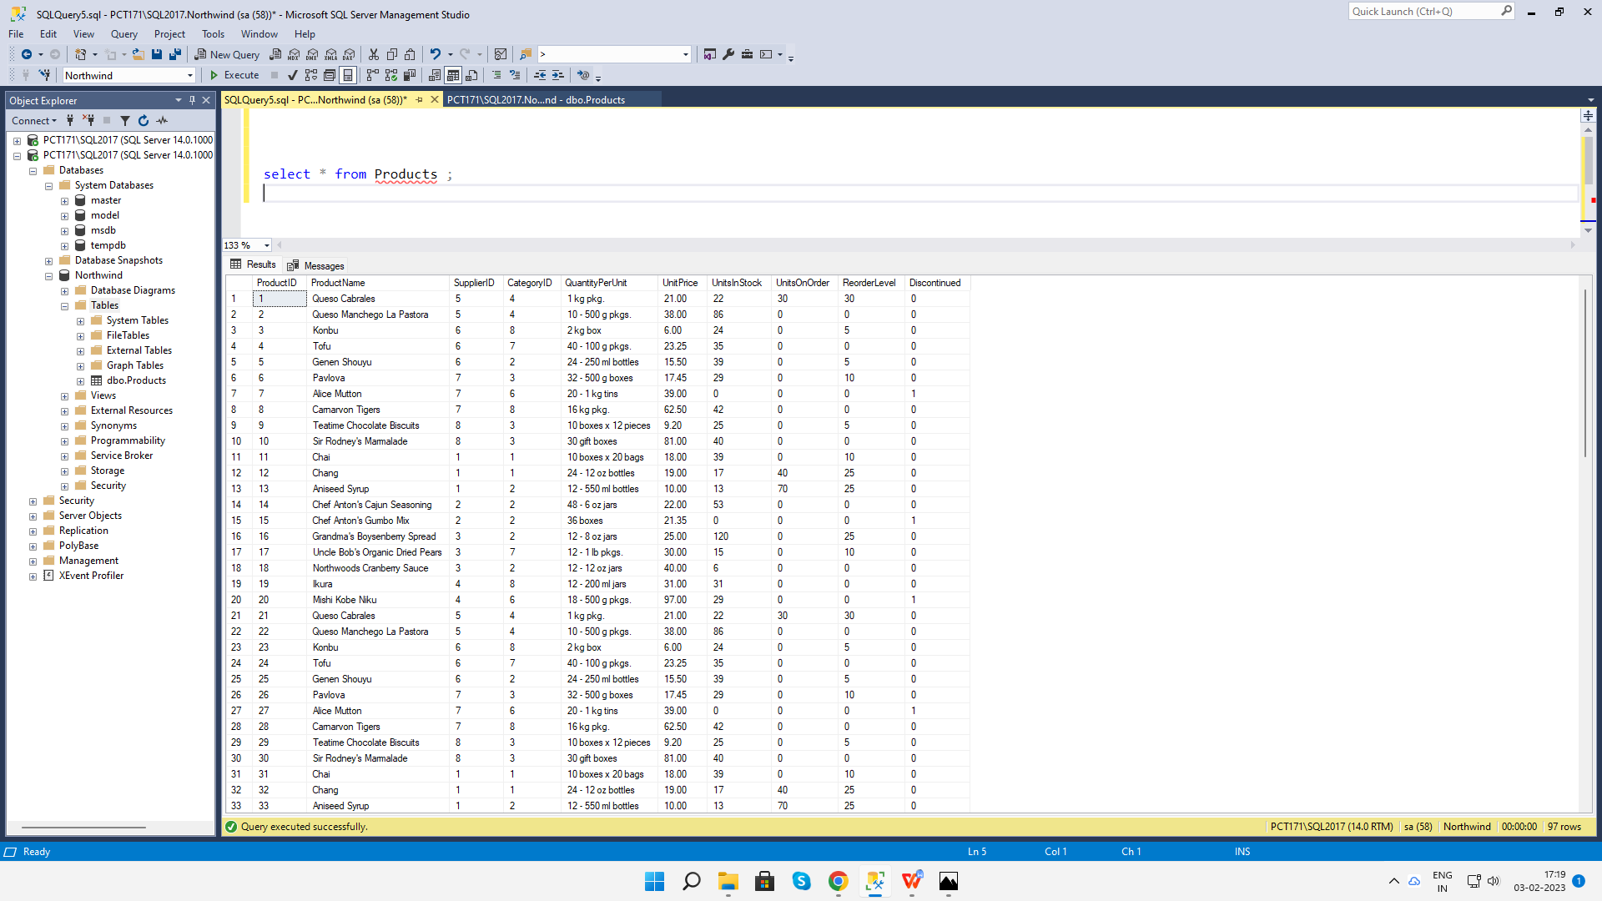

**1. Write a query to get a Product list (id, name, unit price) where current products cost less than $20.**

select ProductID, ProductName, UnitPrice from Products where UnitPrice<20 and Discontinued=0 ;

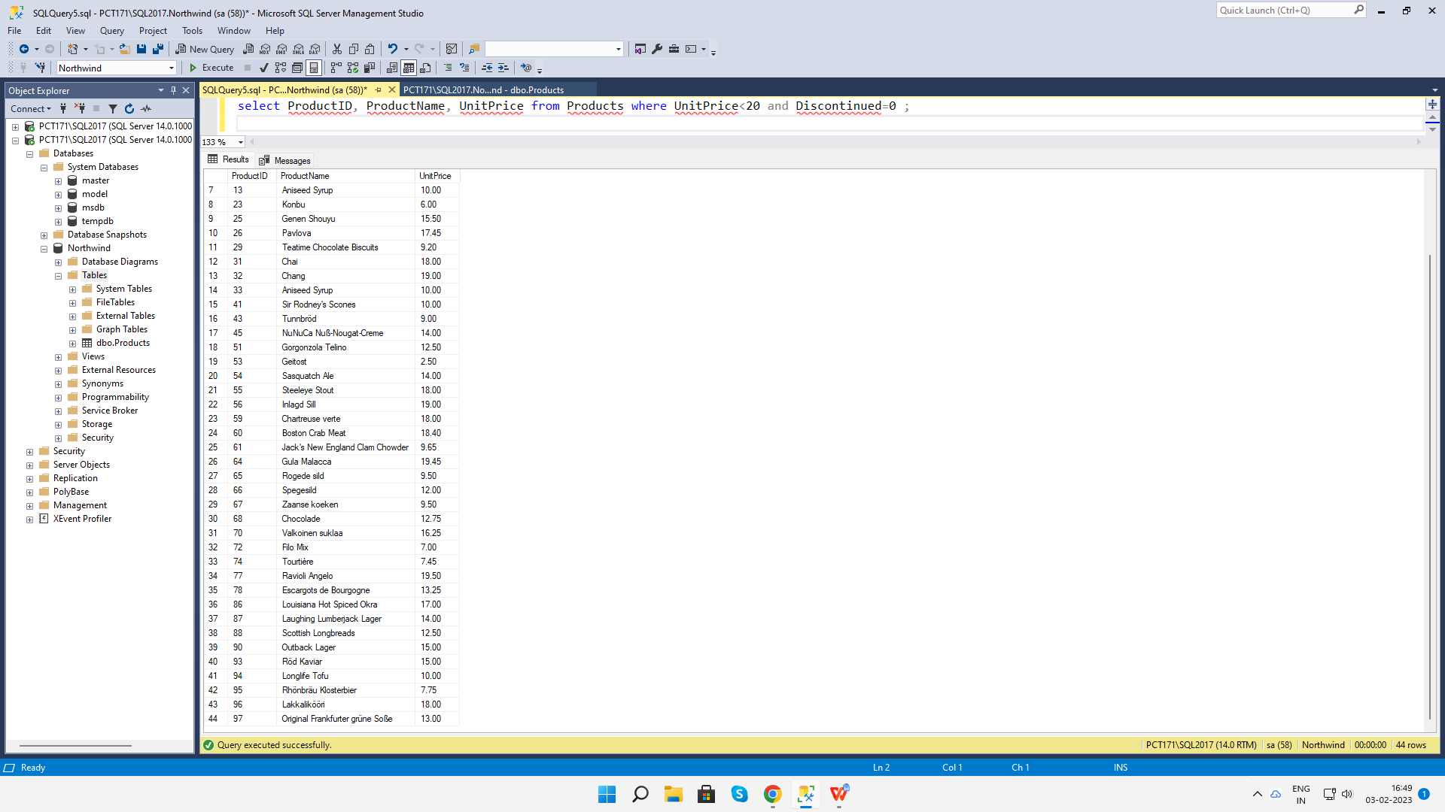

**2. Write a query to get Product list (id, name, unit price) where products cost between $15 and $25**

select ProductID, ProductName, UnitPrice from Products where UnitPrice between 15 and 25 ;

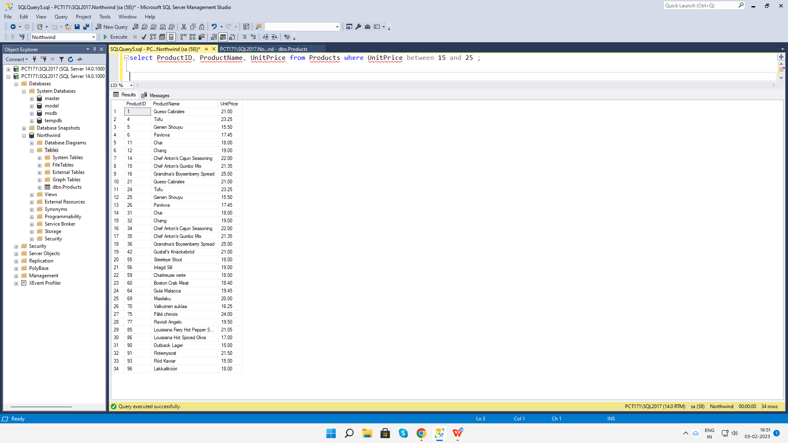

**3. Write a query to get Product list (name, unit price) of above average price.**

select distinct ProductName, UnitPrice from Products where UnitPrice > (select avg(UnitPrice) from Products);

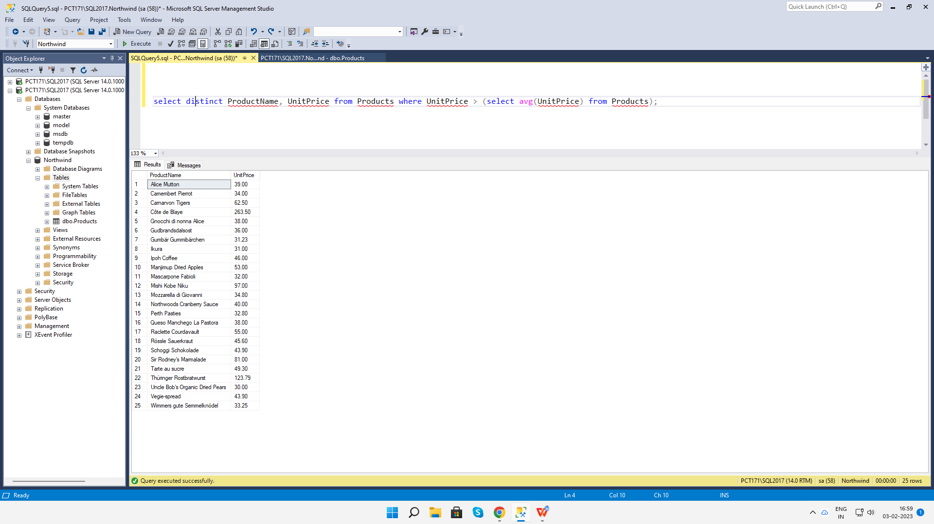

**4. Write a query to get Product list (name, unit price) of ten most expensive** select distinct top 10 ProductName, UnitPrice from Products order by UnitPrice desc;

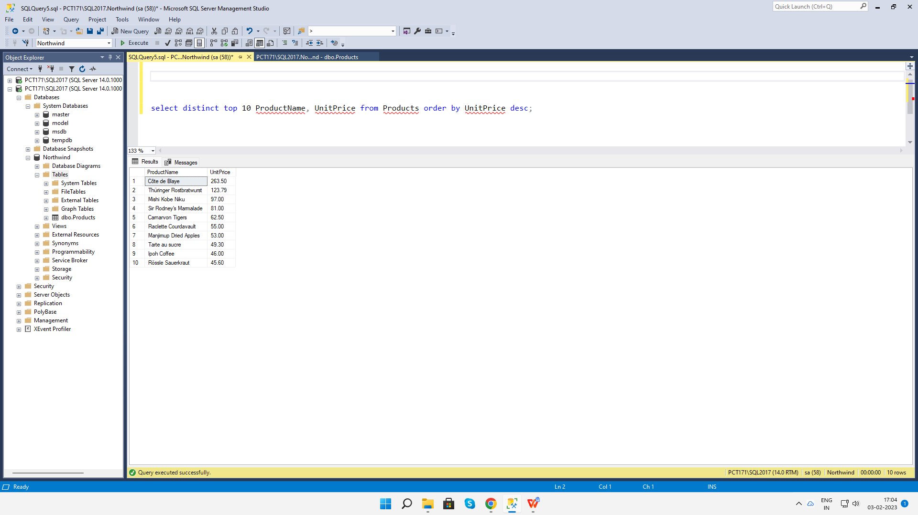

**5. Write a query to count current and discontinued products**

select count( distinct ProductName) from Products group by Discontinued;

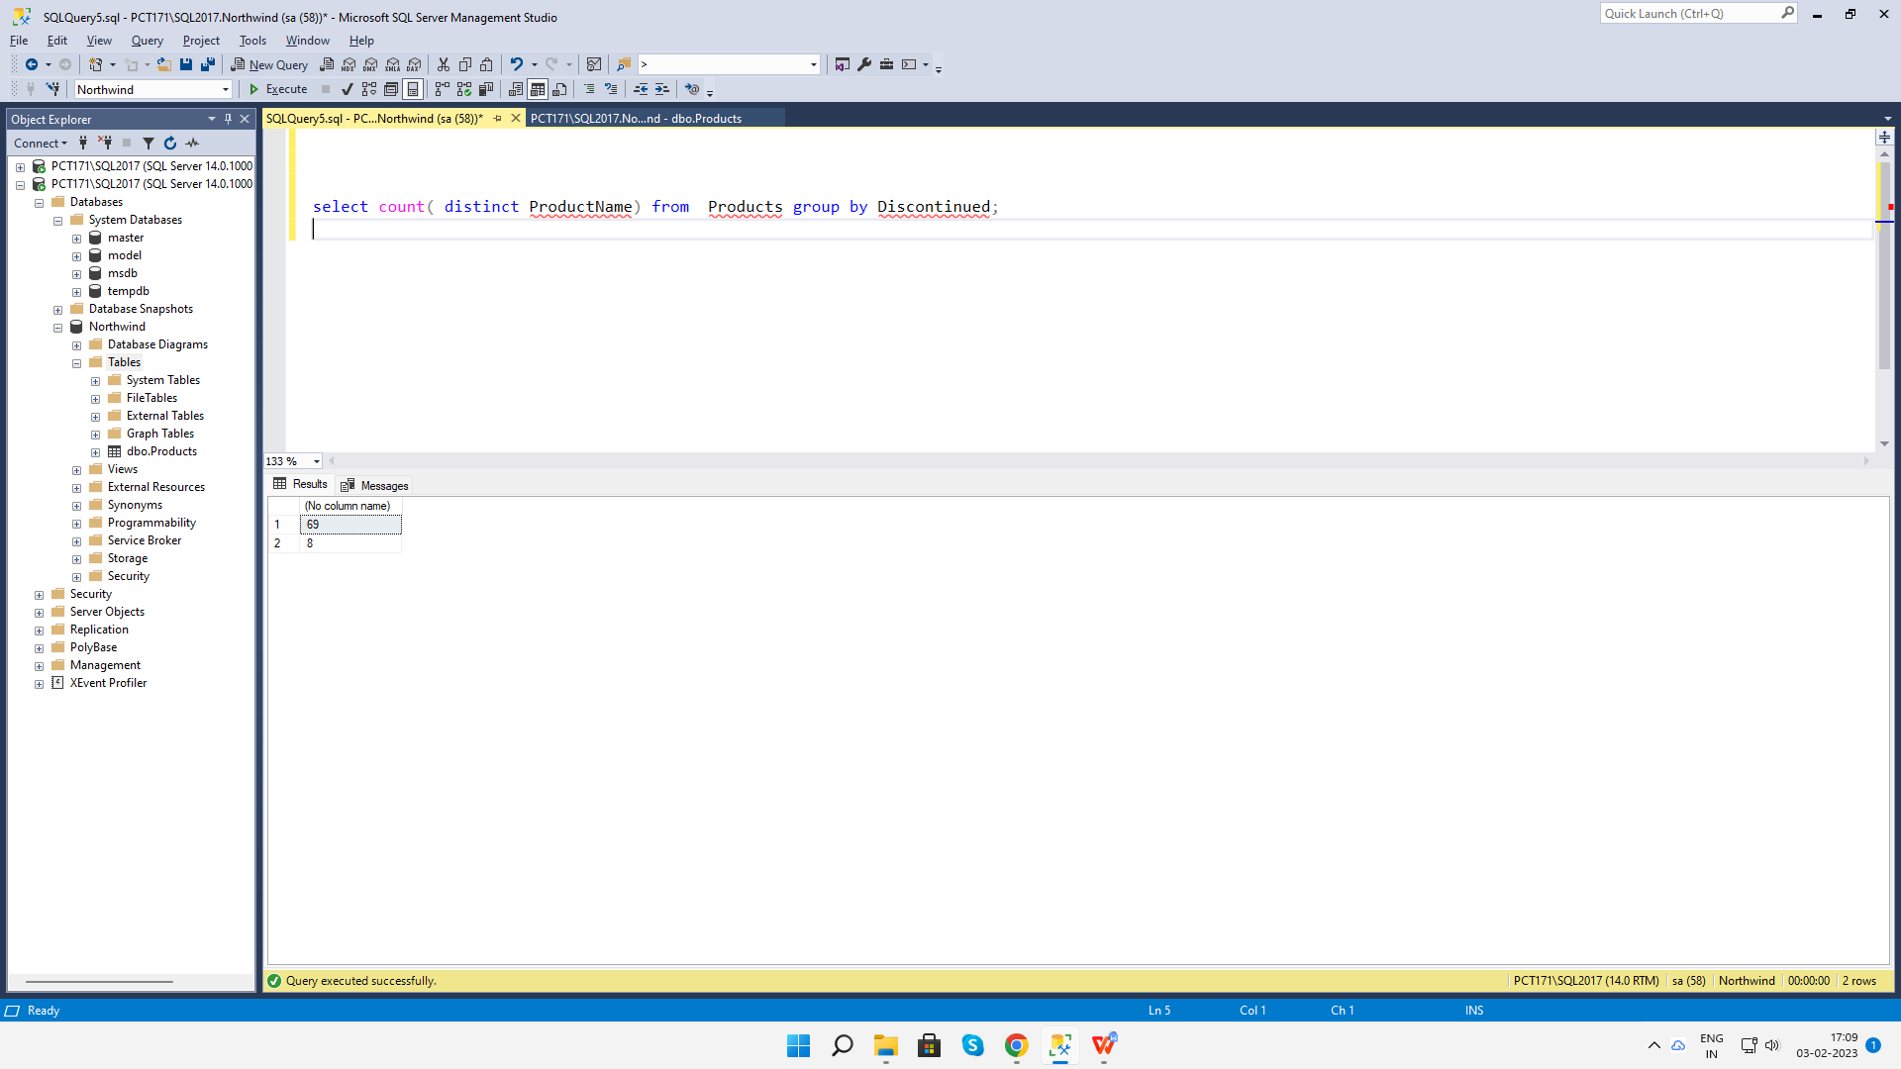

**6. Write a query to get Product list (name, units on order , units in stock) of stock is less than the quantity on order**

select distinct ProductName,UnitsOnOrder,UnitsInStock from Products where (UnitsInStock<UnitsOnOrder);

